**STEPS TO CREATE NEW SITE THROUGH JENKINS**

**Before creating site check for existing site in server and delete(If already created in respective site name)**

**Step 1:** In IIS application, delete site name (**Ex.** pegdemo and cvspegdemo) from sites and application pools.

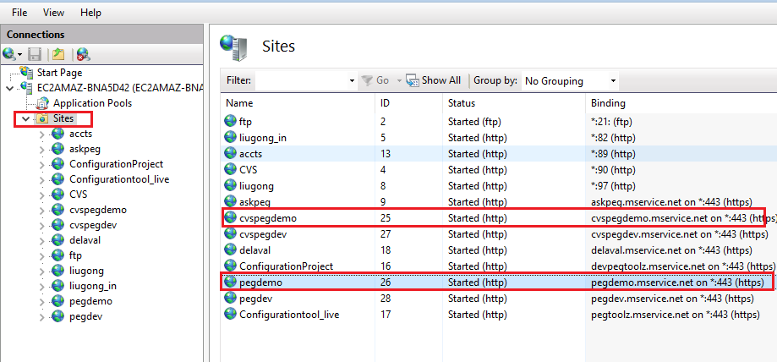

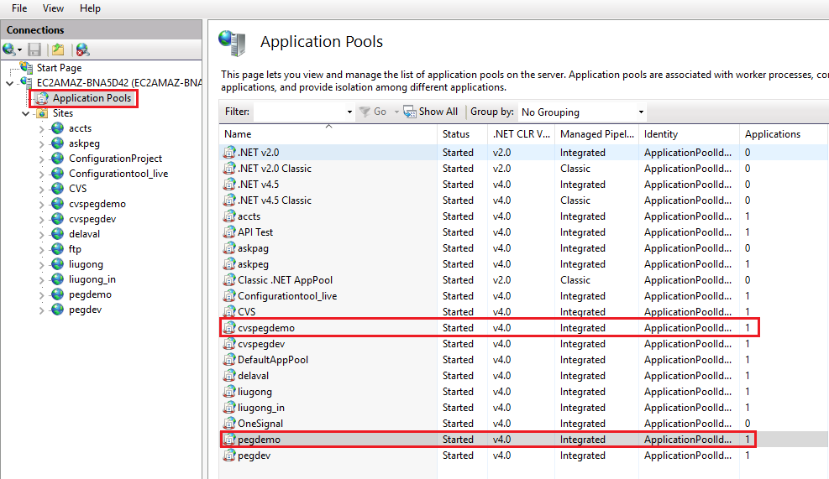

**Step 2:**

* In MS SQL Management Studio, delete database (**Ex.** msv_pegdemo).
* Delete security login from database both app user and process user (**Ex.** peg_in_appuser and peg_in_processuser).

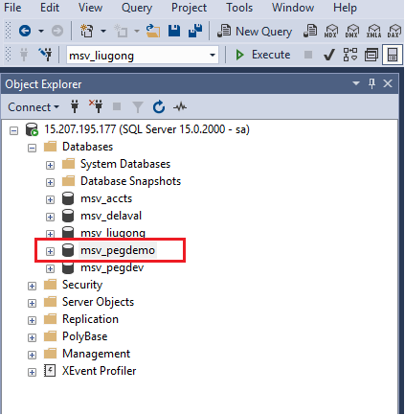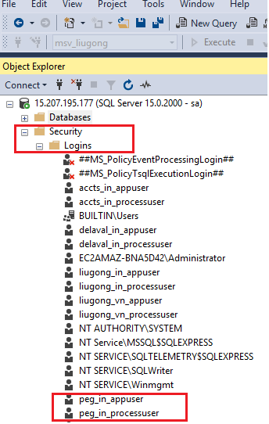

**Step 3:** Delete **site** and **cvs folders** from the path. (**Ex.** inetpub/wwwroot/pegdemo and inetpub/wwwroot/cvspegdemo).

**Step 4:** Delete **notification** and **queue manager** related for the respective site if already available in task scheduler (**Ex.** pegdemo notification and pegdemo queue manager).

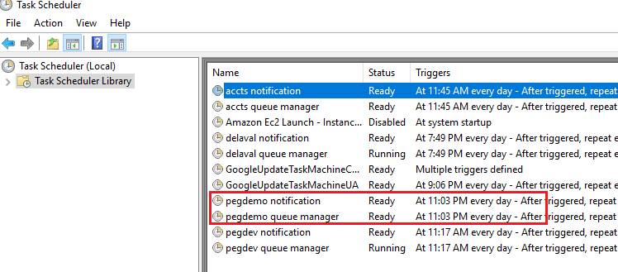

**Below are the steps to create new site**

**Step 1:** Login with Jenkins. (https://jenkins.mservice.net/)

**Step 2:**

* Navigate to **Dashboard/Site Setup/New site** and Click on **Build with Parameter** menu from left nav panel.
* **Project New Site** page will be opened.

**Step 3:** Fill the mandatory field with required inputs to create new site as given below:

|  |  |  |
| --- | --- | --- |
| **Input Field Name** | **Input Field Value** | **Description** |
| requester_mailid | [abc@selfservit.com](mailto:abc@selfservit.com" \o "mailto:abc@selfservit.com) | Site create requester mail id to receive the database and deployment logs |
| client_name | pegdemo | Specify the target client name, in this name the website will be created |
| source_repository | PEG_IN-LIVE | Select the repository name , this will be the base for the new site. |
| clientid | peg | Specify the target clientid . |
| country_code | in | Specify the target country code (ex in , bd, sg, nl, my) |
| locale_id | en-us | Specify the target locale id (ex en-us , vn-vt) |
| target_server_ip | 15.207.195.177 | Specify the target server ip address (ex 35.154.118.188) |
| website_directory | D:\inetpub\wwwroot | specify the target website directory , in this location website will be created (ex C:\inetpub\wwwroot , D:\inetpub\wwwroot). |
| website_port_no | 81 | Specify the target website port no |
| target_cvs_server_ip | 15.207.195.177 | specify the target cvs ip address (ex 35.154.118.188) Leave blank if cvs deployment is not needed |
| cvs_site_name | cvspegdemo | specify the target cvs site name (ex CVS) Leave blank if cvs deployment is not needed |
| cvs_directory | D:\inetpub\wwwroot | Specify the cvs website path (ex D:\inetpub\wwwroot , C:\inetpub\wwwroot) Leave blank if cvs deployment is not needed |
| cvs_port_no | 90 | Give port number which is not used already other sites,specify the target CVS port no Leave blank if cvs deployment is not needed |
| cvs_client_list_env | DEVELOPMENT | Choose the CVS environment to make the client entry in clientlist.xml Choose 'NOT APPLICABLE' if cvs deployment is not needed |
| sql_server_name | 15.207.195.177 | specify the target SQL server ip address where the new database will be created (ex 3.6.28.86) |
| db_name | msv_pegdemo | specify the target DB name (ex msv_acopco), this database will be created in sql server. |
| db_user_name | sa | specify the target DB user name (ex sa) to login into sql server |
| db_password | ******* | specify the target DB Password |
| db_appuser | peg_in_appuser | specify the target DB appuser name (ex acopco_in_appuser) , this user will be created in sql server and configured in web config file. |
| appuser_password | AppUser22# | specify the target DB Appuser password |
| db_processuser | peg_in_processuser | specify the target DB processuser name (ex acopco_in_processuser) , this user will be created in sql server and configured in web config file. |
| Processuser_password | ProcessUser22# | specify the target DB Processuser password |
| super_admin_name | pegadmn | Specify the super admin name (ex acopcoadmn) , this will be configured in web config file. |
| super_admin_password | AdmnPwd22 | Specify the super admin password, this will be configured in web config file. |
| notification_smtp_client | smtp.gmail.com | Depends on clients the input data will get change.  As of now apply the default values only. |
| notification_smtp_username | [msvsite@mservicelive.com](mailto:msvsite@mservicelive.com) |
| notification_smtp_password | [SITmsv@2021#](mailto:SITmsv@2021) |
| notification_smtp_portno | 587 |
| notification_subject_name | Test service |
| support_smtp_client | smtpout.asia.secureserver.net |
| smtpServerName_queue | smtp.gmail.com |
| smtpUserName_queue | [l3exceptions@mservicelive.com](mailto:l3exceptions@mservicelive.com) |
| smtpPassword_queue | L3Mservice2018# |
| smtpPortNo_queue | 587 |
| to_mailid_queue | [abc@selfservit.com](mailto:abc@selfservit.com" \o "mailto:abc@selfservit.com) | Specify "to mailid" for queue manager notfication (ex abc@selfservit.com) |
| cc_mailid_queue | [xyz@selfservit.com](mailto:xyz@selfservit.com" \o "mailto:xyz@selfservit.com) | Specify "cc mailid" for queue manager notfication (ex xyz@selfservit.com) |

**Step 4:** After filling all the required fields Click on **Build** button.

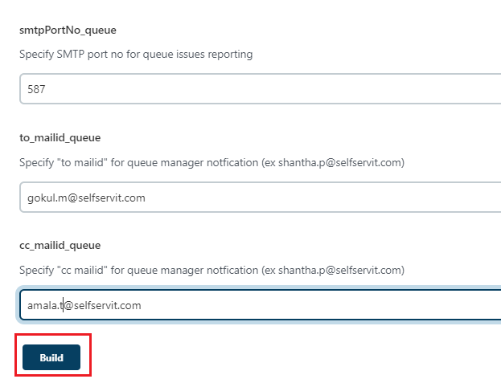

**Step 5:** After successful build, check whether following items created successfully.

* **IIS - Sites and Application Pool** - pegdemo and cvspegdemo
* **Site** - D:/inetpub/wwwroot/pegdemo
* **CVS site** - D:/inetpub/wwwroot/cvspegdemo
* **DB** - msv_pegdemo

**Step 6:** In IIS mask IP address to URL. This has to do for both site and cvs site

* Click on **Sites** and select respective site (Ex: pegdemo, cvspegdemo)
* From right panel click on **Actions/Edit Site/Binding**. **Site Bindings** pop up will get opened.
* Click on **Add** button in Site binding. **Add site bindings** popup will get opened
* Select type as **https**, IP address as **All Unassigned** and port as **443**  
   Host name as required URL (Ex: pegdemo.mservice.net, cvspegdemo.mservice.net ), select the **checkbox of Require Service Name Indication** and SSL Certificate as **\*mservice.net**
* Click on **Ok** button.

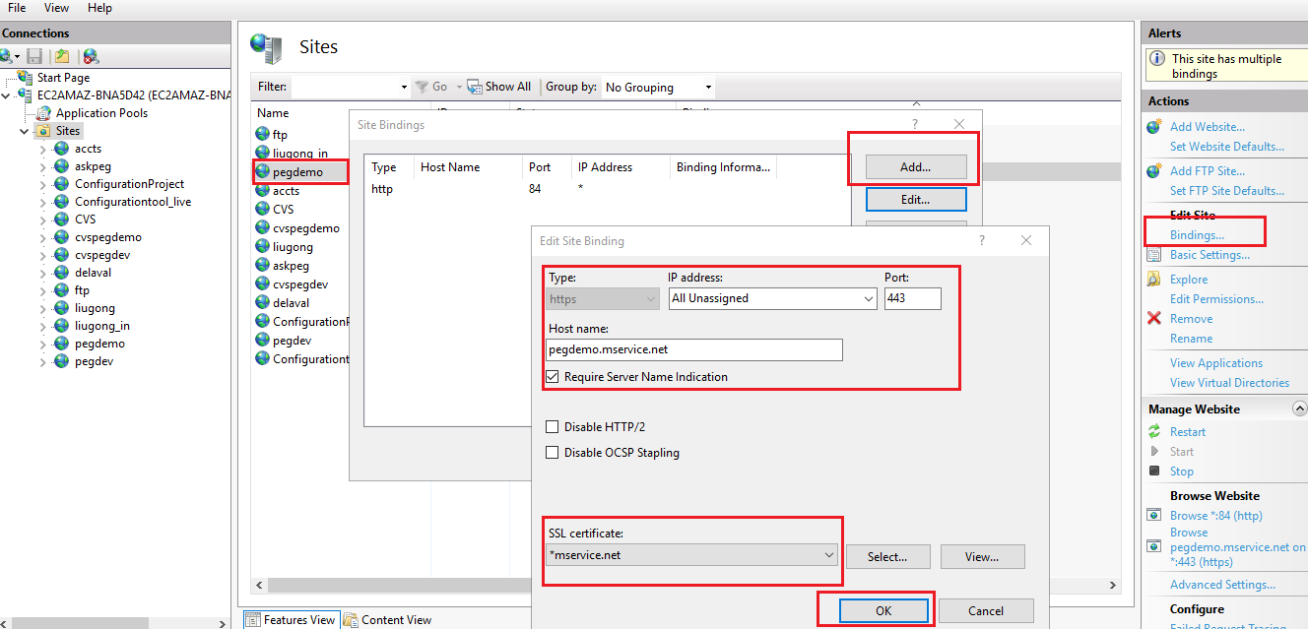

**Step 7:** Update **web.config.xml** which is in **D:/inetpub/wwwroot/pegdemo**

Open web.config.xml go to connection_string node:

* Update name value of app user - **conn_pegapp to conn_peg_in_app**
* Update name value of process user - **conn_pegprocess to conn_peg_in_process**

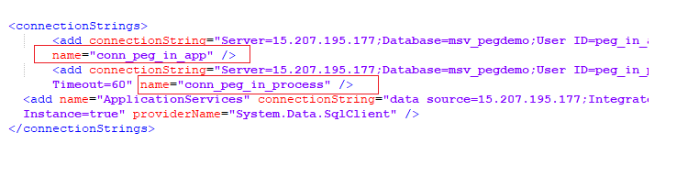

**Step 8:** Update masked URL in the following places:

* Web.config.xml  
  Update IP address to url in **appclientconfig/userlist/add** node for the attributes **domain_url** and **customer_feedback_url** (https://pegdemo.mservice.net)
* cvspegdemo/access_package/client_functional_access.xml  
  **protocal_type** - https:

**domain_name** - pegdemo.mservice.net

**port_no** - make as empty node

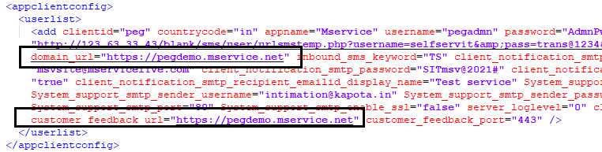

**Step 9:** Connect app CVS to respective environment in demo server

* Open demo server (IP: 3.111.114.220).
* Open **CVS/democvs.mslite.com/client_list.** Depends on environment path location get change  
  Update **client_list** node with below content according to your requirement  
  **<clientid>**

**<countrycode>**

**<cvs_protocol_type>https</cvs_protocol_type>**

**<cvs_domain_name>cvspegdemo.mservice.net</cvs_domain_name>**

**<cvs_port_no />**

**</countrycode>**

**</clientid>**

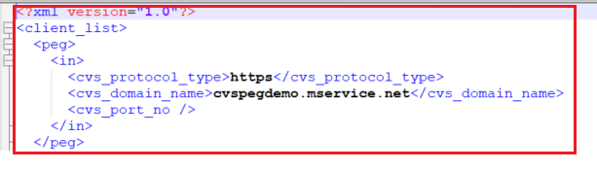

**Step 10:** After completion of above steps, update **last_change_timestamp.xml** in   
**access_package and configuration_package** to current date and time(Ex. 20221221095100)

**Step 11:** Update bin folder

* Pick bin folder in the following path from github : (peg-knowledgebase\Framework\updated sit bin folder).
* Copy and past in created site folder(pegdemo).

**Step 12:** Update Masked URL in Task Scheduler for queue manager

* Right click on the created queue manager (Ex : pegdemo queue manager)
* Click on properties, properties setting popup get opened.
* Click on actions from popup menu bar.
* Select the action from the list, click on Edit button.
* Edit action window get opened in that update masked url in Add arguments(optional) .